Unified Airport Operations Center

Astrikos Airport Solution
Astrikos' airport solution brings together operational data from multiple airport systems into a common intelligence and decision-making layer. The demo includes a unified dashboard with digital-twin visualization, live KPIs, system-health monitoring and flight information, providing airport stakeholders with a common operational picture.

Key Challenges Addressed
- Fragmented airport operations and systems
Airport functions such as passenger processing, baggage, airside operations, security, infrastructure and transportation often operate across multiple systems. Astrikos addresses this through a unified operational view across airport functions and connected systems.
- Limited real-time visibility across airport operations
Operators need a common picture of what is happening across the airport rather than monitoring individual systems in isolation. The U-ApOC dashboard brings together live KPIs, digital-twin views, system health and flight information.
- Predictive rather than Reactive operations
Conventional monitoring identifies issues after they occur. Astrikos introduces AI-driven predictions and advisories to identify potential risks and enable teams to act before they become operational incidents.
- Passenger congestion and service-level challenges
Passenger movement, queues and bottlenecks across check-in, security, immigration, baggage and gates can directly impact journey time and flight operations. The solution provides end-to-end passenger-flow visibility and predicts emerging bottlenecks.
- Operational impact of disruptions and incidents
Events such as weather disruptions, baggage failures, security incidents or system failures can cascade across airport operations. Astrikos enables predictive alerts, scenario simulation and coordinated response across affected functions.
- Lack of coordination between operational stakeholders
Airport operations require multiple departments to respond to the same event. The platform provides a shared operational picture and supports coordinated actions across functions such as airside, terminal, security and infrastructure.
- Unplanned equipment and infrastructure failures
Reactive maintenance can result in operational disruption and emergency interventions. Astrikos uses asset-health data and predictive analytics to identify potential failures early and support preventive maintenance.
- Inefficient incident and emergency response
Emergency situations require fast, standardized and coordinated actions. The SOP Console enables predefined airport playbooks to be triggered and executed with actions and compliance tracked.
- Limited ability to optimize airport resources and infrastructure
Airport resources such as parking, terminal capacity, runways, baggage systems and other infrastructure need to be continuously optimized based on changing operational conditions. The demo demonstrates AI-supported optimization and scenario-based decision-making.
- Energy, sustainability and operational efficiency pressures
Airports need to balance operational performance with energy consumption and environmental objectives. The solution provides visibility into energy, carbon, water and waste performance and supports identification of optimization opportunities.

Astrikos Airport Management System Demo

The Astrikos Airport Management System demo showcases how S!aP can provide a unified operational view of the airport through a U-ApOC interface, bringing together passenger operations, terminal systems, airside operations, landside transportation, security, maintenance, sustainability and commercial functions. The platform goes beyond monitoring by using AI-driven predictions and advisories to identify potential risks, support timely decisions and enable coordinated action.
The demo is designed to show how an airport can move from reactive monitoring to predictive and intelligent operations.

Important Modules/ Simulations

Baggage Simulation
The button on this header opens the baggage handling system as a live simulation — bags in system, carousel load, throughput and power draw, with an event log running alongside. Use Trigger Event to raise a belt jam and watch the AI response.

- In the terminal & Passenger Subsystem, click on “Baggage Simulation”
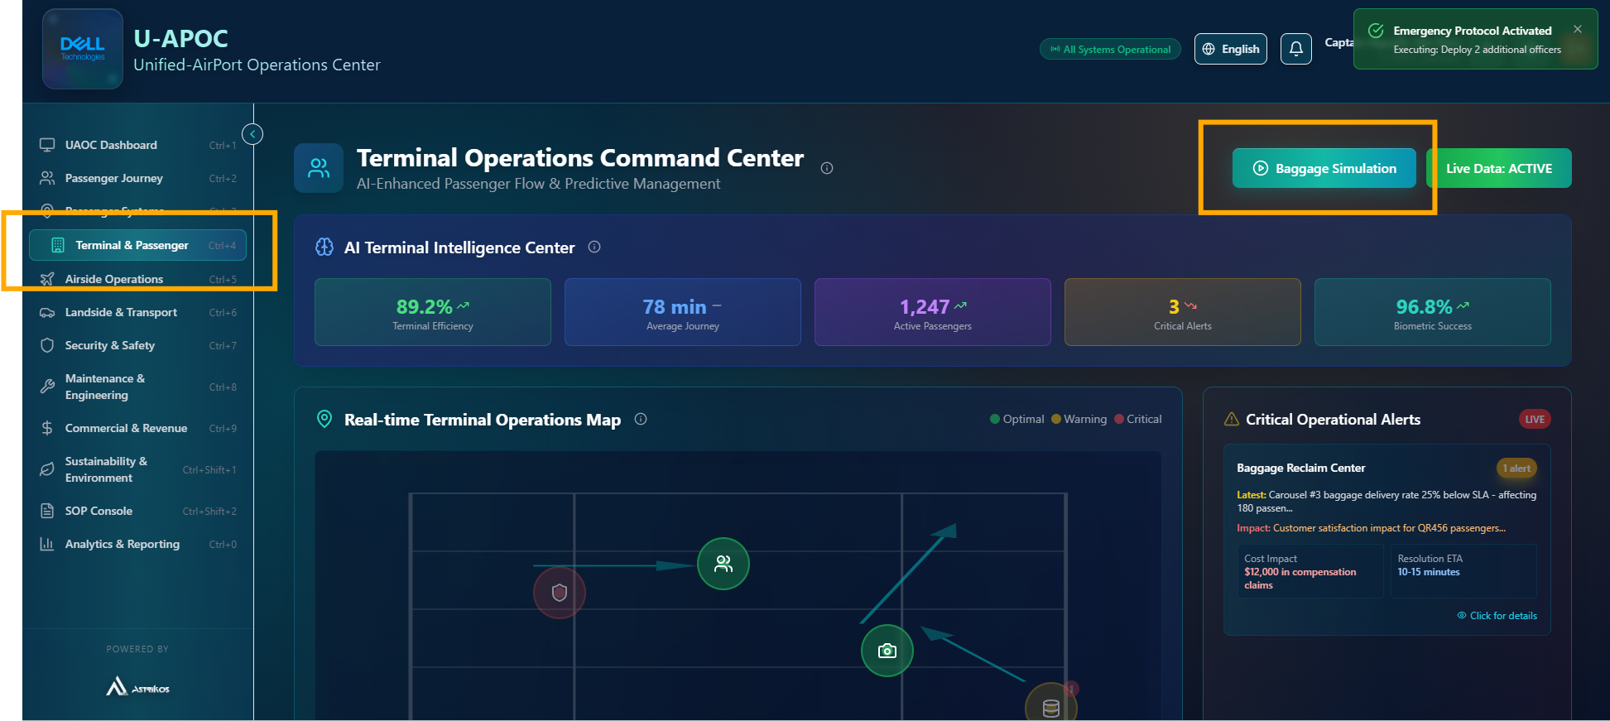

- In the Baggage Simulation, click on Operations tab.
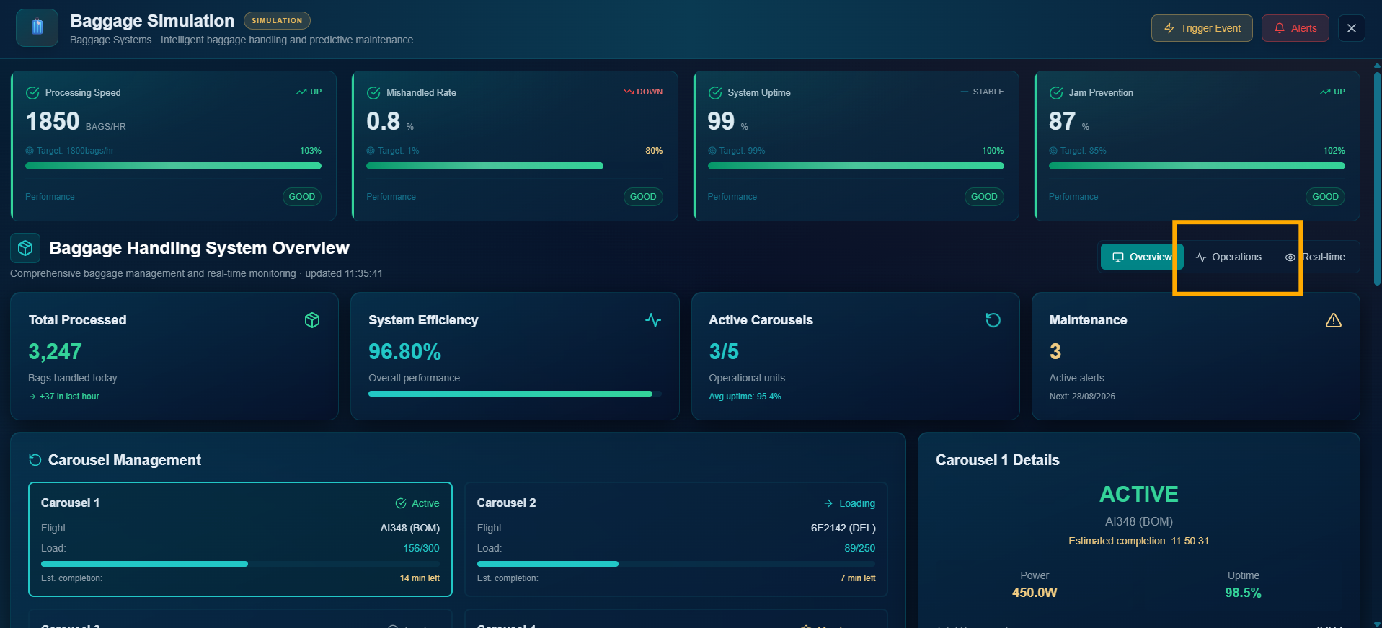

- Click on type of Baggage Simulation and Next click top buttons “Explosive, Weapon or Suspiscious” for specific Scenario.
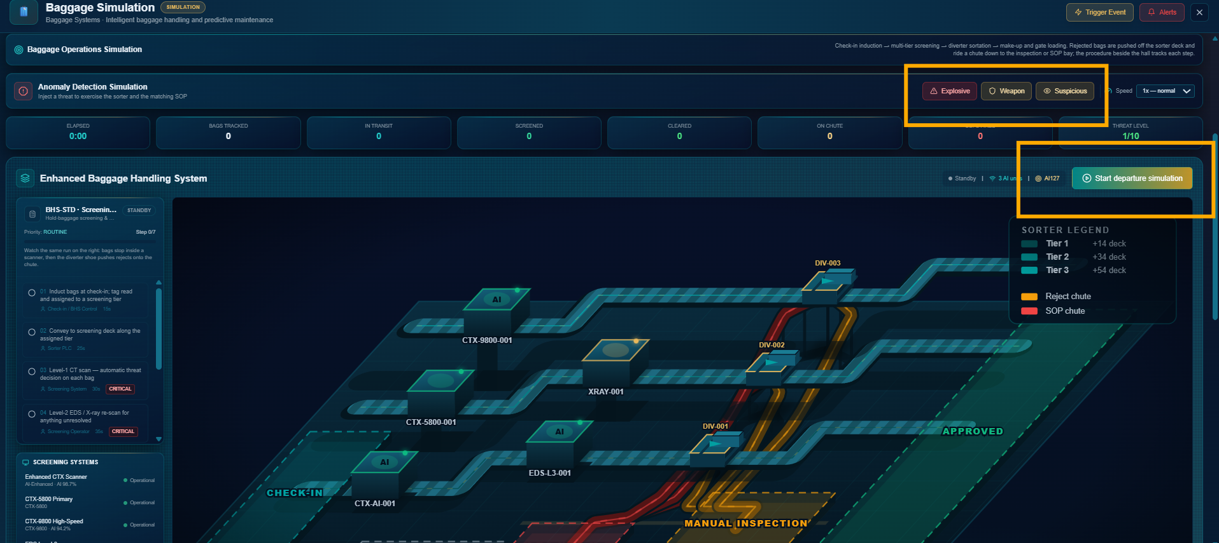

- You will see the baggage moving along the belts based on the type of Baggage simulation selected.
On the Left Hand Side you can see the Real-time AI Advisory and SOP / Workflow.

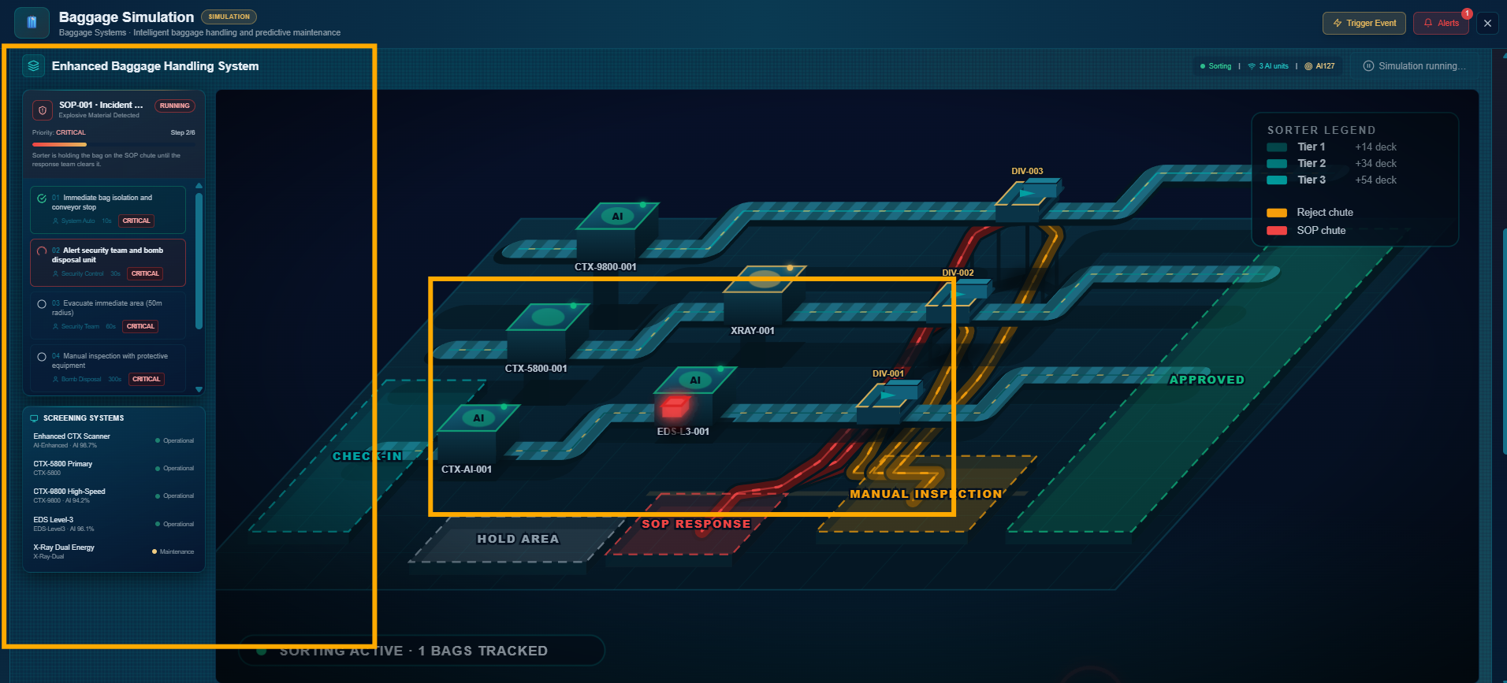

Flight Operations Simulation
Real-time runway and taxiway management
The AI advisory band tracks runway efficiency, average taxi time, active movements, fuel savings and weather impact. The body of the screen is the surface movement map — live aircraft positions, movement trails and highlighted conflict zones — supported by the TOBT/TSAT optimization timeline, taxi-time trends, runway occupancy and current weather.
The header holds the three decisions this desk actually makes: Ground Stop, Close Runway and Weather Redirect. Each one changes the numbers on the screen rather than just logging an intent.

- Within the Airside Operations subsystem click on Flight Operations Simulation
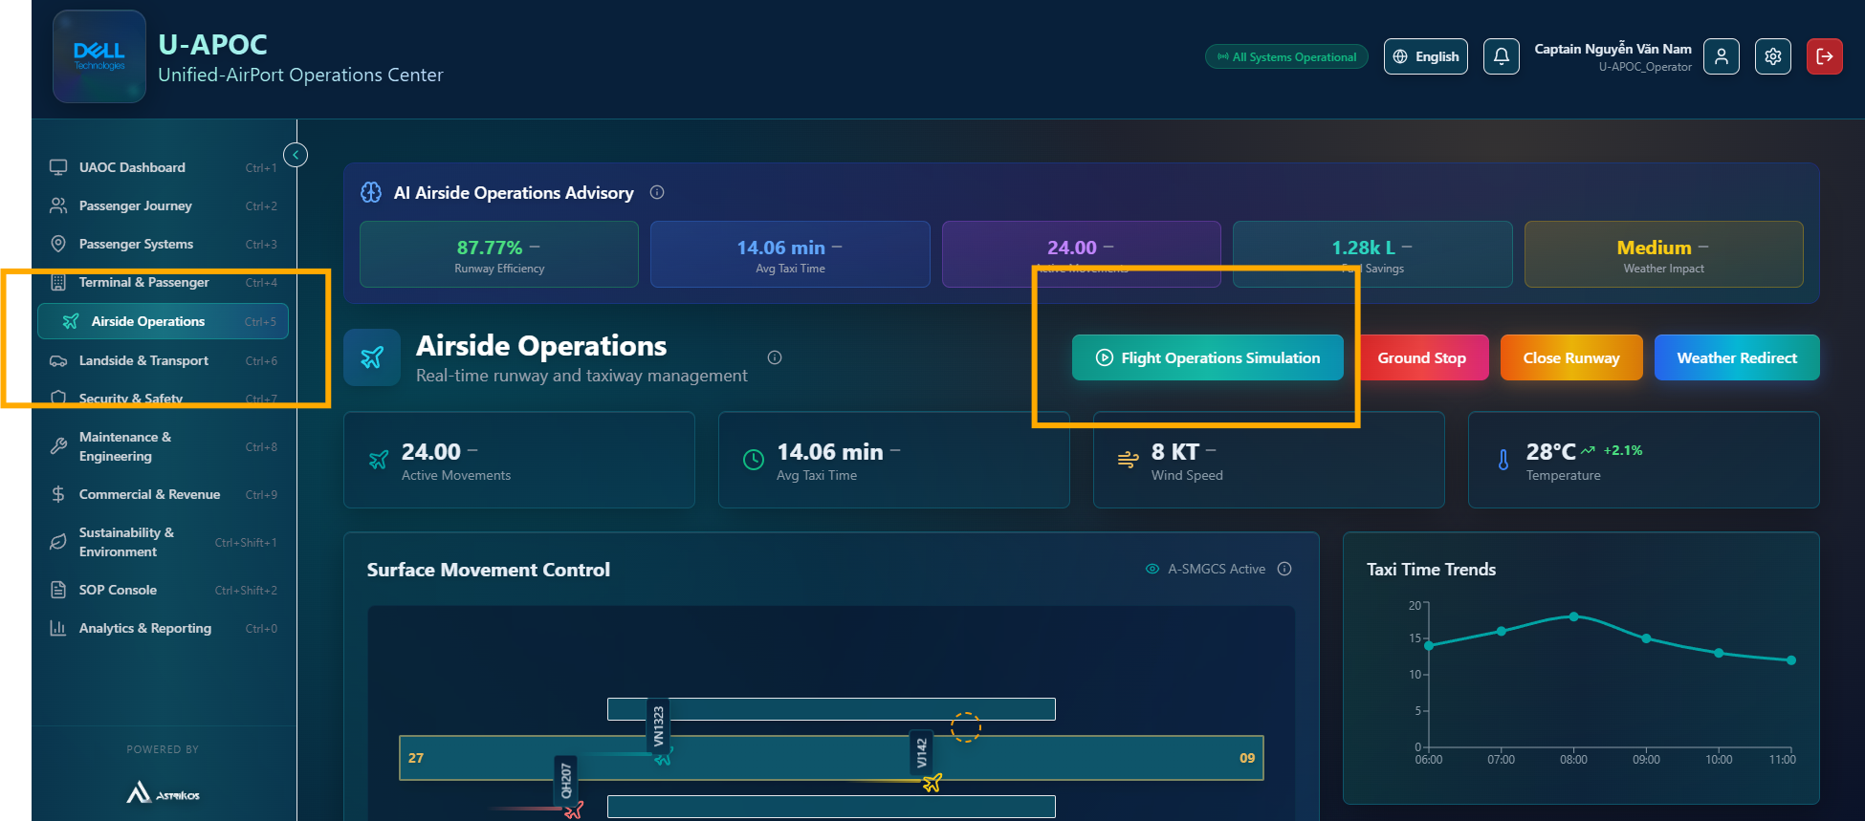
- Just above the “Simulate AO-S flight operation” button you can select the “Aircraft, Runway or Gate”
and click the “Simulate AO-S flight operation” button to start the Simulation

- You will see the Aircraft moving based on the simulation configurations selected.
On the Left Hand Side you can see the Real-time AI Advisory and SOP / Workflow.

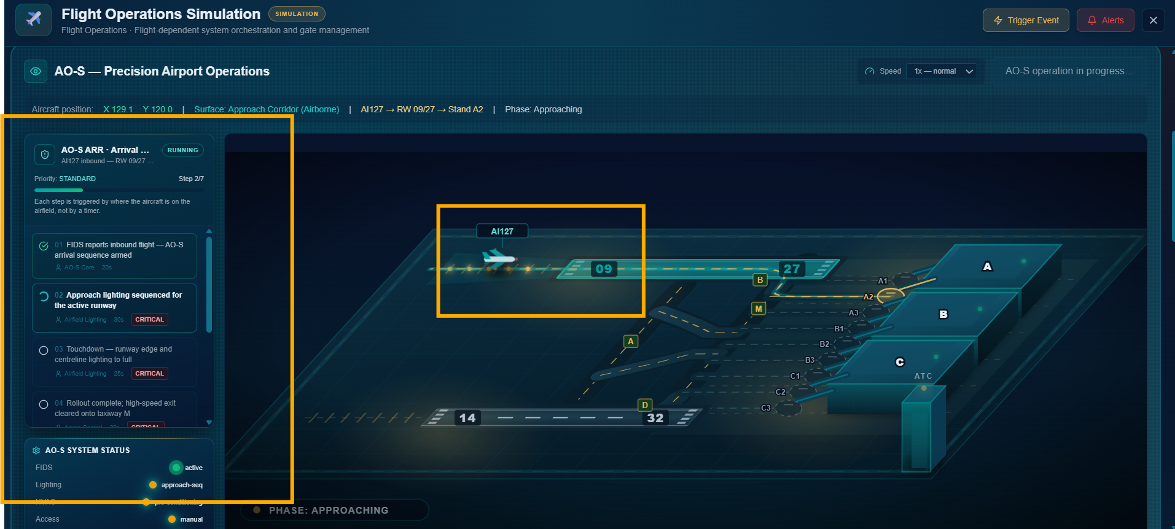

Security Simulation

- In the Security & Safety Subsystem, click on “Security Simulation”.

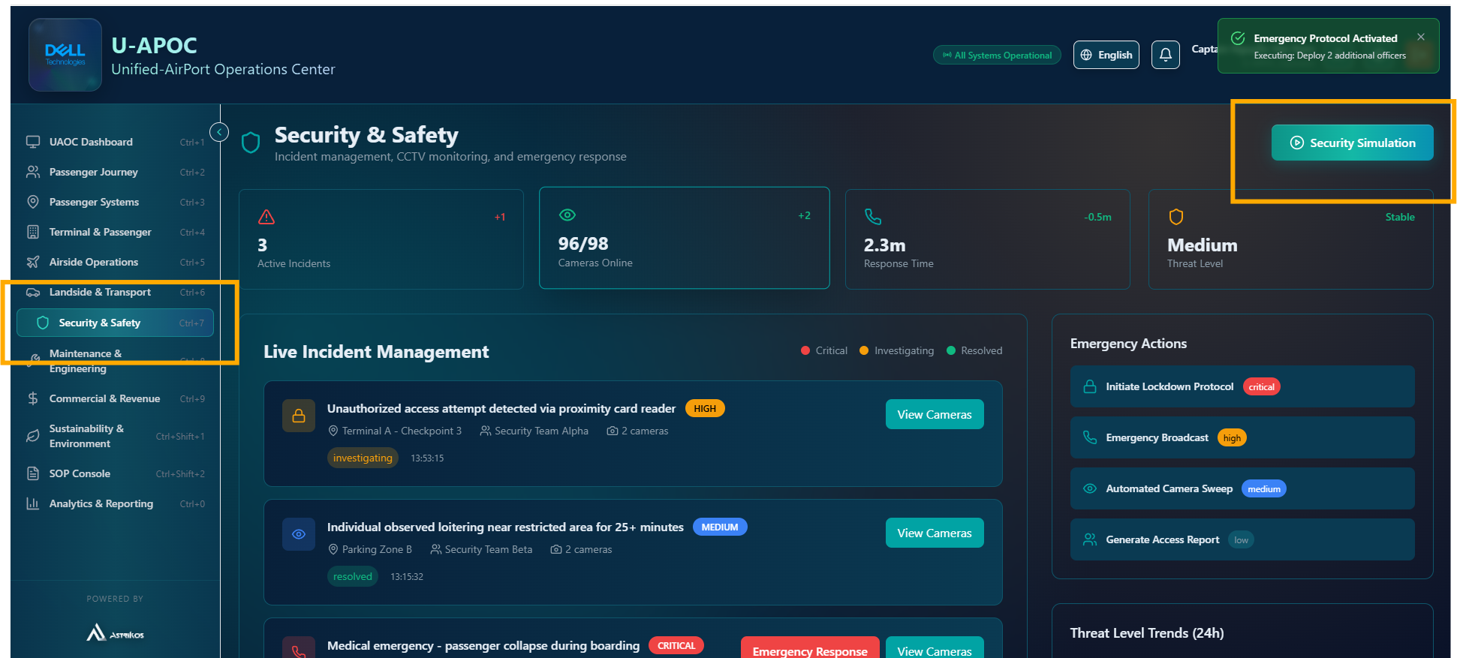
- Click on “Simulate unattended bag incident”.
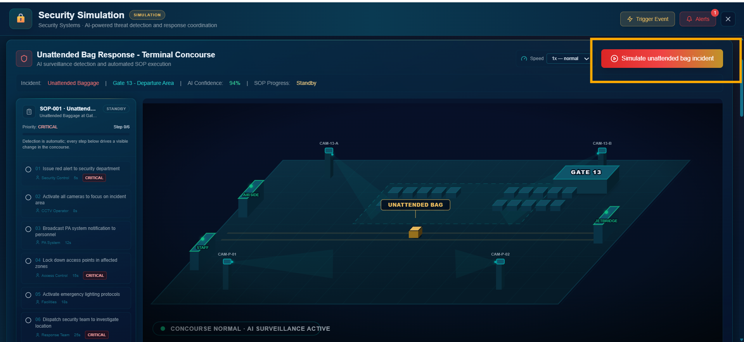

- You will see the Unattended bag visible on the floor in the simulation.
On the Left Hand Side you can see the Real-time AI Advisory and SOP / Workflow.

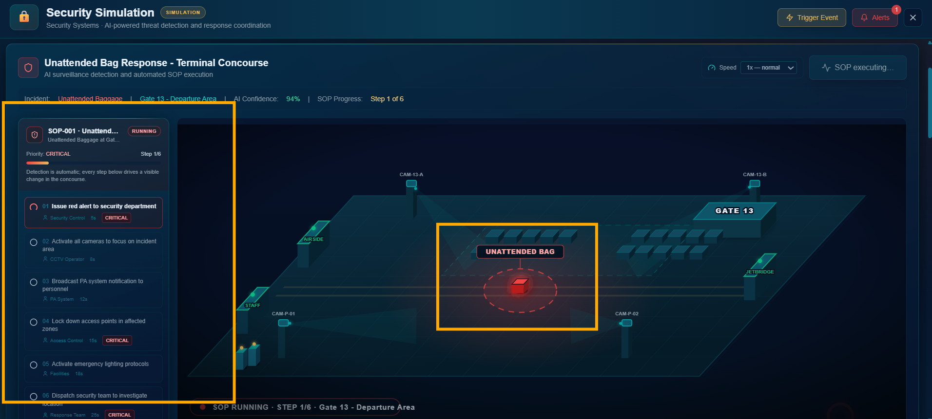
- On Scrolling Down, the Live CCTV Feeds will be visible.
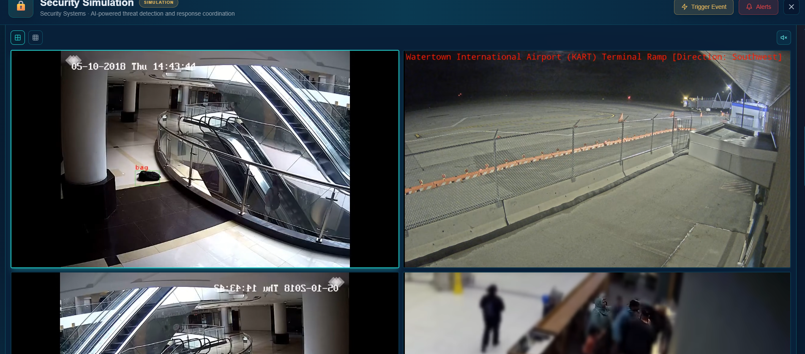

Subsystems
UAOC Dashboard
The U-ApOC Dashboard provides a unified, real-time operational view of the airport, bringing together AI-driven predictions, digital-twin visualization, airport KPIs and the health of critical airport systems in a single interface. It enables airport operators to move from monitoring current conditions to anticipating risks and taking proactive action.
Scenario:
The U-ApOC dashboard detects an approaching thunderstorm and predicts that it could cause approximately 45 minutes of flight delays starting at 16:30. Instead of waiting for delays to occur, the airport operator receives an early AI advisory on the dashboard.
How the screen is used:
- Detect – AI identifies the upcoming weather impact.
- Assess – The operator opens the prediction to review the risk level, AI confidence and contributing factors such as weather conditions, resource availability and historical performance.
- Decide – The system recommends an optimization action/SOP based on the predicted impact.
- Act – The operator can execute the recommended SOP or first run it in shadow mode to assess the expected outcome.
- Track – The action history records whether the optimization was applied, manually overridden or completed.
Value:
This allows the airport to anticipate the disruption, understand why it is being predicted, and take proactive action before the weather event translates into widespread operational delays.

Passenger Journey
The Passenger Journey module provides an end-to-end view of the passenger experience across key airport touchpoints, from terminal entry and check-in through security, immigration, baggage, boarding and aircraft entry. It combines passenger-flow KPIs, queue and wait-time monitoring, SLA compliance and a digital twin to identify bottlenecks and understand their impact on overall journey time.
The module uses AI-driven passenger-flow analysis to identify emerging congestion and recommend actions such as staff reallocation or activation of express processing lanes, helping airport teams proactively optimize passenger flow and service levels.

Passenger Systems
Provides a unified technical monitoring view of critical passenger-processing systems such as CUPPS, CUSS, PTS, SACS, BHS and PCDS. It tracks system health, performance, connectivity and integration status to help operators identify failures or degradation early and take corrective action before passenger operations are impacted.

Terminal & Passengers
Provides a real-time operational view of terminal activities and passenger flow, including terminal capacity, congestion, baggage operations and critical alerts. It uses AI-driven insights to identify emerging bottlenecks, predict operational impact and recommend timely actions to improve terminal efficiency and passenger experience.

Airside Operations
Provides real-time visibility and AI-driven management of aircraft movements, runway and taxiway operations. It monitors runway efficiency, taxi times, runway occupancy, weather conditions and fuel savings while providing optimization recommendations for flight operations

Use Case – Taxi Time & Runway Optimization:
The system identifies that Flight VN1323 can be shifted from its current TOBT/TSAT of 10:25 to an optimized time of 10:28, with an estimated 45L fuel saving and 89% confidence. The operator can review the recommendation and apply it, helping reduce taxi delays and improve overall runway efficiency.

Landside & Transport
Provides visibility and optimization of kerbside operations, parking, traffic flow and transport modes around the airport. It monitors vehicle movement, parking utilization, search times, pickup/drop-off congestion and revenue, with AI-driven recommendations for improving efficiency and resource utilization.
Use Case – Dynamic Parking Optimization:
The system predicts high demand for Zone A – Premium parking and provides an AI recommendation to increase pricing from $25K to $30K, with 89% confidence and an expected $2.4K revenue impact. This enables the airport to dynamically manage parking demand while improving utilization and revenue.

Security & Safety
Provides a centralized view of airport security incidents, CCTV status, threat levels and emergency response. It enables operators to monitor and investigate incidents in real time, access relevant camera feeds, and initiate coordinated emergency actions such as lockdowns, broadcasts and automated camera sweeps.

Maintenance & Engineering
Provides centralized visibility into asset health, predictive maintenance, work orders and maintenance performance, helping airport teams identify potential equipment failures and manage preventive or corrective maintenance.
Use Case – Predictive Maintenance:
The system detects abnormal vibration in a baggage belt motor and predicts that bearing replacement will be required within 72 hours. A predictive work order is automatically raised and assigned to the maintenance team, allowing the issue to be addressed before it causes a baggage-handling disruption.

Commercial & Revenue
Provides a centralized view of airport revenue streams, commercial performance, customer satisfaction, and AI-driven revenue opportunities across retail, food & beverage, parking, and VIP lounge services. It helps airport teams identify underperforming areas and optimize pricing, promotions, and service offerings.

Sustainability & Environment
Monitors the airport’s energy consumption, carbon emissions, waste diversion, and water usage, providing performance tracking against sustainability targets and visibility into renewable energy adoption and environmental initiatives.

SOP Console

Centralizes the airport’s Standard Operating Procedures (SOPs), enabling operators to execute, monitor, and automate operational and emergency workflows while tracking execution performance, compliance, and success rates.

Analytics & Reporting
Provides a centralized view of airport performance through automated reports, operational analytics, data-source monitoring, predictive insights, and industry benchmarking, enabling data-driven decision-making.
Use Case:
Executive Performance Monitoring – Airport management can generate and schedule operational, safety, financial, and executive reports to track KPIs, identify performance trends, and compare airport performance against defined benchmarks.

